NMRS installation using Docker on Windows 10+
Introduction
Docker is a platform that allows you to develop, deploy, and run applications within lightweight, isolated containers. Containers are a form of virtualization that packages an application and its dependences together in a consistent and portable unit. This enables you to create, test, and deploy applications in a consistent environment across different systems and environments, such as development, testing, and production. NMRS installation using docker also allows the sharing of one modules folder across the NMRS containers.
Requirements for a single instance of NMRS.
- A computer with Windows 10 operating system (Tested on Core i7).
- NMRS war file.
- NMRS custom modules.
- Docker desktop installer.
- docker-compose.yml file.
- Dockerfile.
- Internet connection.
Procedures
- Install Docker desktop for windows. Click here to download.
- Update windows susbsystem linux if prompted. Open Command Prompt as Administrator and type: wsl --update
- Create a folder on your desktop and name it nmrs_docker_windows (please use lower case)
- Copy the docker-compose.yml and the my.cnf, the .env file into the folder you created above.
- The directory structure should look like this:
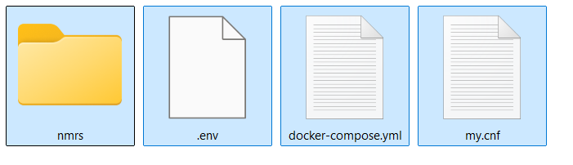
- The nmrs folder will map to the openmrs root directory in the container for easy module deployment, runtime properties file edit, etc)
- Important: Edit your credentials in the .env (You can create one if it is not available).
- Make desired changes to the docker-compose.yml (or just review it to know the basic parameters).
- The my.cnf file is mounted as a volume to enable easy configuration of the mysql server. (innodb_log_buffer_size, sql_mode, innodb_buffer_pool_size, etc).
- Open this directory with the above contents in the command prompt.
- Type this command at the prompt: docker-compose up -d
- If successful, you should see an output on the command prompt like the screenshot below:
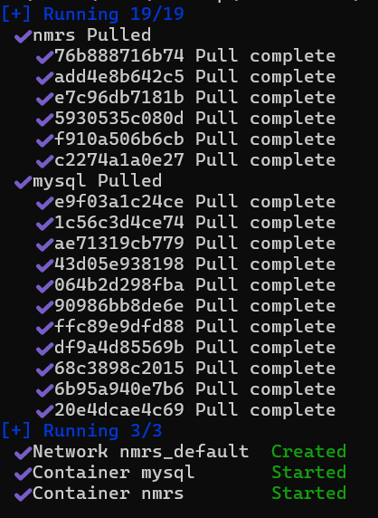
- When you open the Docker desktop application and click containers, you should see the containers running as shown below.

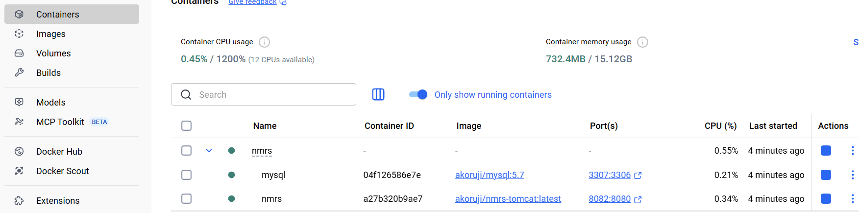

- Use your preferred database management software like Navicat or MySQL workbench to access the database connection using the connection details in the docker-compose.yml
- Create your desired database.
- Import your desired database.
- Open your web browser and type for example this address to deploy the war file: http://localhost:8085/openmrs/initialsetup (you can replace the port: 8085 with your configured external port number for the tomcat container).
- Click the right arrow to proceed.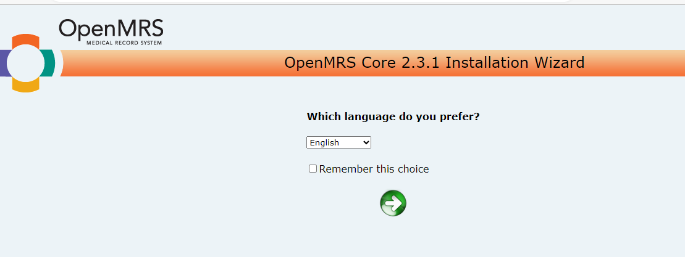

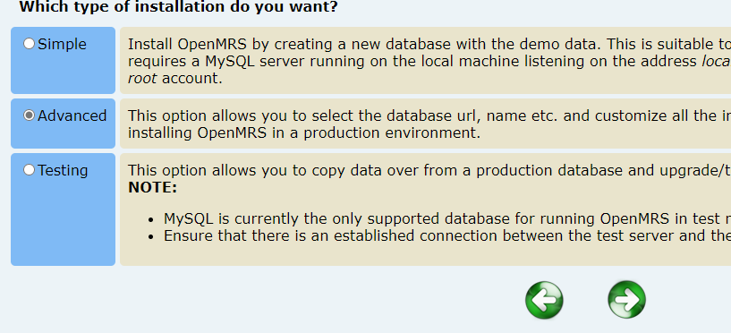
- Click advanced and the right arrow to proceed.

- At the next page, under database connection, change localhost to mysql. This is the mysql service name you created earlier in the docker-compose.yml:
From
To

- If you have imported your database as required in step 14, you should select yes and specify your database name as shown below and click the right arrow to proceed.
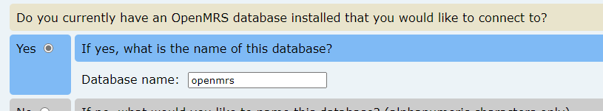

- At the next page, type your database username and password and click the right arrow to proceed.
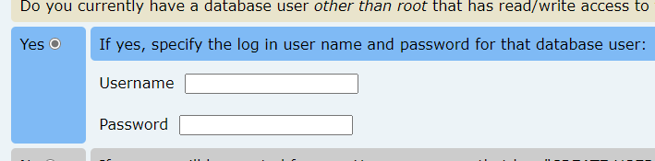

- At the next page, click the right arrow to proceed.
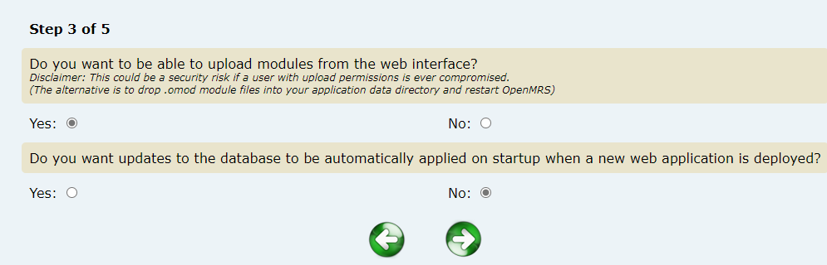

- At the next page, take note of the location of the runtime properties as shown below then click the right arrow to proceed:
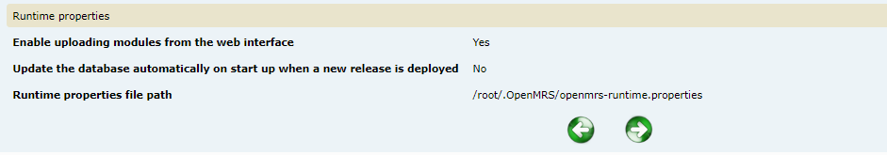
- Wait for the installation to complete
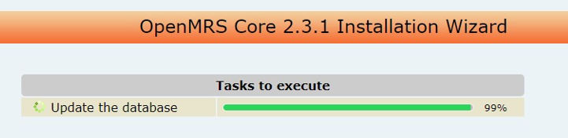
- Go to Docker desktop app and click containers. Locate your tomcat container and click on the 3 vertical dots under Actions column and click Restart.
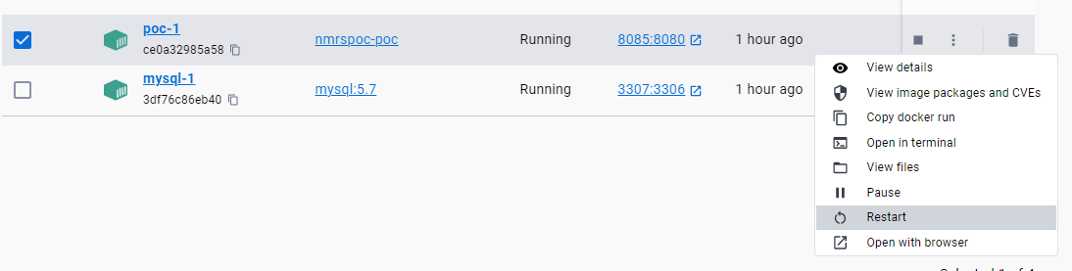
- Go to your browser and refresh the NMRS page and wait for the page to load.
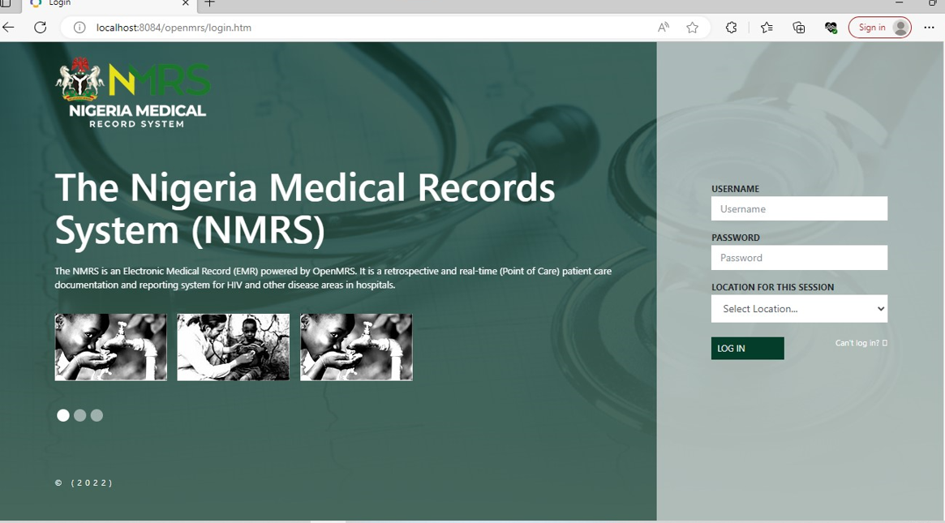

For more information please contact: hi@ihvnigeria.org

